## 📄 Task 1: Deploy the Application

**Objective:** Deploy a Node.js application to Kubernetes and confirm that it is running and healthy.

### 🛠 Deployment Steps

1. Created a Kubernetes Deployment using the deployment.yaml manifest file.
2. Deployed the application using kubectl apply.
3. Verified the Pod reached the **Running** state and is **Ready**.
4. Inspected the Pod for health and container status.

### 📸 Screenshots

* **Screenshot 1:**

kubectl apply -f deployment.yaml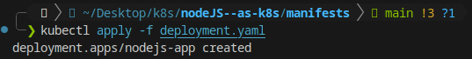

* **Screenshot 2:**

kubectl get pods  
(Verifies the Pod is running and in Ready state)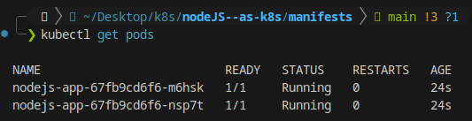

* **Screenshot 3 (optional but recommended):**

kubectl describe pod <pod-name>  
(Shows container has no errors and is running normally)

### 

### ✅ Outcome

The Node.js app was successfully deployed. The Pod is up, running, and responding as expected.